ELECTRICITY CONSUMPTION ANALYSER

1. INTRODUCTION
The Smart Electricity Consumption Analyzer is a web-based intelligent dashboard that helps users analyze, visualize, and predict their household or industrial electricity usage.
This project combines Python (Flask framework), Machine Learning (Linear Regression), and Plotly data visualization to make energy monitoring interactive and intelligent.
Traditional power meters only display instantaneous readings, providing limited insight into consumption trends. This project automates that process — allowing users to:
- Calculate power and energy consumption.
- View interactive charts of real-time usage.
- Predict future consumption patterns using machine learning.
This analyzer not only helps users understand their energy usage but also aids in cost management and energy efficiency planning.
Electricity has become an indispensable part of modern life — powering homes, industries, and businesses worldwide. With the increasing demand for energy, effective monitoring and analysis of electricity consumption have become crucial for sustainable usage and cost management. However, traditional analog meters and even basic digital meters only display instantaneous readings, making it difficult for users to interpret long-term consumption trends or identify power wastage.
The Smart Electricity Consumption Analyzer aims to bridge this gap by combining data analytics, machine learning, and interactive visualization into a single intelligent web application.
Developed using Python (Flask framework), the system allows users to input their electrical parameters such as voltage, current, and duration of usage. The application then calculates power (in kW), energy consumption (in kWh), and estimated cost based on predefined electricity tariff rates.
To go beyond basic calculations, the project integrates a machine learning model (Linear Regression) that predicts future power consumption based on historical data. This helps users forecast their upcoming electricity usage and bills, enabling better financial and energy management. The visual component of the project is implemented using Plotly, a modern data visualization library that generates interactive, real-time charts directly in the browser. These charts display trends in power and energy over time, giving users a clear, data-driven understanding of their energy profile.
From a technical standpoint, the project showcases the integration of Flask (for web backend), HTML/CSS (for frontend design), Pandas/Numpy (for data handling), and Scikit-learn (for predictive analytics). This multidisciplinary approach combines concepts from Artificial Intelligence, Data Science, and Web Development — demonstrating the practical application of computational thinking and data-driven decision-making.
In the broader context, the Smart Electricity Consumption Analyzer can be extended into a full-fledged IoT-enabled energy monitoring system. By connecting hardware sensors such as current sensors (ACS712) and microcontrollers (ESP32), real-time readings can be automatically captured and displayed on the same web dashboard. This transforms the project from a simulation-based tool into a live smart energy management platform.
Overall, this project encourages efficient electricity usage by providing users with actionable insights and predictive analytics. It serves as a foundation for smart grid systems, home automation, and AI-driven sustainability applications. Through intelligent data interpretation and visualization, the Smart Electricity Consumption Analyzer not only promotes awareness of energy consumption patterns but also supports the global initiative toward energy conservation and sustainable living.

2. PROBLEM STATEMENT
In today’s modern world, the demand for electricity is increasing rapidly due to the growth of industries, urbanization, and the rising use of electrical appliances. However, most households and organizations still lack intelligent systems to monitor, analyze, and optimize their electricity usage effectively. Traditional electricity meters merely record total energy consumption, offering no insights into when, where, or how the electricity is being used. As a result, users often receive high electricity bills without understanding the specific causes or the consumption patterns behind them.
The absence of real-time analytics and predictive insights makes it difficult for individuals and industries to make data-driven decisions regarding their power consumption. For instance:
- Users cannot track hourly or daily variations in their power usage.
- There is no automatic alert or recommendation when consumption exceeds normal levels.
- Predicting future electricity usage or estimating monthly bills accurately is nearly impossible with conventional tools.
- Industrial setups with multiple devices or machines find it challenging to pinpoint which equipment consumes the most energy.
Additionally, the manual process of calculating power (P = V × I), energy (E = P × t), and cost is time-consuming and prone to human errors. Without automation, energy management remains reactive instead of proactive — users act only after receiving high bills, rather than preventing excess usage in real time.
To address these challenges, there is a need for an intelligent, automated, and user-friendly system that can:
- Accept voltage, current, and duration as input.
Automatically compute power and energy consumption.
- Display the results through an intuitive web dashboard with interactive graphs.
- Predict future energy usage using machine learning techniques.
- Estimate the cost based on energy tariffs and provide insights for better power management.
The Smart Electricity Consumption Analyzer project was developed to solve these issues. It transforms raw electrical data into meaningful visual and predictive insights, empowering users to:
- Understand consumption trends easily,
- Forecast their future usage, and
- Optimize energy usage for sustainability and cost efficiency.

3. OBJECTIVES OF THE PROJECT
The primary objective of this project is to design and implement a Smart Electricity Consumption Analyzer that can calculate, visualize, and predict power usage
This project aims to transform raw electrical readings into meaningful insights that help users monitor their energy consumption effectively and make informed decisions toward energy efficiency.
Main Objectives
- To automate power and energy computation:
Develop a system that takes voltage, current, and duration as inputs, and automatically calculates power (kW), energy consumption (kWh), and the estimated electricity cost.
- To build an interactive user interface:
Design a user-friendly web interface using HTML, CSS, and Flask that allows users to input data easily, view results, and navigate to a real-time dashboard.
- To visualize electricity usage data:
Implement dynamic charts using Plotly or Chart.js to display trends such as power vs. time and energy vs. time, enabling users to understand their usage behavior through visual insights.
- To apply machine learning for consumption prediction:
Train a Linear Regression model on historical data to predict future energy consumption or power demand, helping users estimate upcoming bills and manage load efficiently.
- To estimate and compare energy cost:
Provide an automated billing estimation feature based on a predefined tariff rate (₹ per kWh), allowing users to predict monthly expenses and control overconsumption.
- To promote energy awareness and optimization:
Encourage users to analyze patterns, identify wastage, and adopt energy-saving practices through data-driven insights provided by the dashboard.
- To integrate AI and data science principles in real-world applications:
Demonstrate how data collection, preprocessing, visualization, and prediction can be combined in a single system — showcasing the practical application of AI and computational thinking concepts.
- Secondary / Future Objectives
- To extend the system for IoT-based real-time monitoring:
Integrate hardware components such as current sensors (ACS712) and ESP32 microcontrollers to collect live readings and send them automatically to the web dashboard.
- To enable multi-user access and personalization:
Add authentication and account-based features so different users can track their own device or household consumption data.
- To incorporate alert and recommendation systems:
Send automated alerts when power usage exceeds thresholds and provide AI-generated suggestions for optimizing energy consumption.
Outcome
By achieving these objectives, the project will serve as a comprehensive energy management tool — capable of analyzing, predicting, and optimizing electricity consumption using a combination of AI, web development, and data visualization techniques.

4.BLOCK DIAGRAM OF THE PROJECT
The Smart Electricity Consumption Analyzer consists of several functional modules connected in a logical flow from user input to final visualization and prediction. The block diagram represents the structure and working of the system in a simplified form.
In summary, the project architecture follows a sequential data flow model starting from user input, moving through computation and prediction, and ending with visualization. This modular design makes the system scalable, allowing for easy integration of IoT sensors and advanced analytics in the future.
a). User Input (Voltage, Current, Hours)
- Users enter electrical parameters such as voltage, current, and usage hours.
- These inputs are collected through the web form (front-end interface).

b)Flask Backend Application
- Processes the input data and performs calculations for power and energy.
- Acts as the main controller connecting all other modules.

c) Machine Learning Model (Predicts Future Usage)
- Uses past data to predict future electricity consumption patterns.
- Helps estimate upcoming energy demand and cost.

d)Data Visualization Layer (Plotly Graphs & Dashboard)
- Displays analysis and predictions using interactive graphs and charts.
- Makes the data easier to interpret for users through visual dashboards.

e). Output Dashboard (Power, Energy, Cost, ML)
- Shows final computed values such as power, energy, cost, and predictions.
- Acts as the user’s main display to view all analytical and forecasted data.

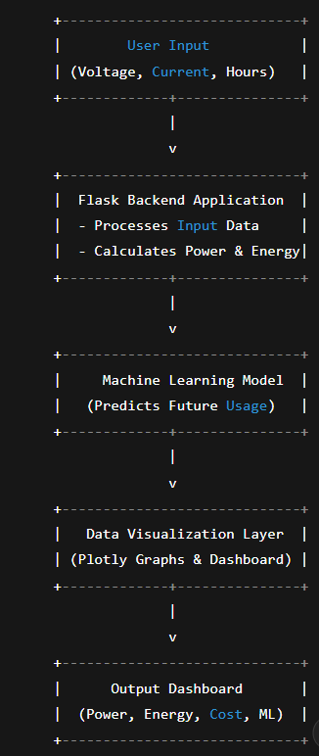
- MODULES OF THE PROJECT
The Smart Electricity Consumption Analyzer is divided into several interconnected modules, each performing a specific function in the overall workflow of the system. These modules ensure a systematic approach to collecting data, processing it, applying machine learning, and displaying the results to the user.
The main modules of the project are described below.
a.Input Interface Module
This module is responsible for collecting the user’s input values such as voltage (V), current (A), and usage time (hours).
  - Developed using HTML and Flask templates.
  - Provides an easy-to-use web form where users can enter data.
  - The input data is sent to the Flask backend for processing.
  - Ensures validation of user input to avoid calculation errors.
b.Backend Computation Module
This is the processing core of the system, where all the main calculations are performed.
  - Uses Python Flask as the backend framework.
  - Performs automatic computation of:
Power (kW) = (Voltage × Current) / 1000
Energy (kWh) = Power × Time
  - Estimates the cost of energy consumption based on a fixed tariff rate (for example, ₹6.5 per kWh).
  - Prepares data for machine learning and visualization modules.
c.Machine Learning Module
This module applies predictive analytics to forecast future power consumption.
  - Uses the Linear Regression algorithm from scikit-learn.
  - Trains the model with sample or past energy data.
  - Predicts the next hour or next day’s consumption.
  - The output helps users anticipate energy demand and future bills.
d.Data Visualization Module
The visualization module presents analytical results in the form of interactive charts and graphs.
  - Developed using Plotly for web-based data visualization.
  - Displays Power vs Time and Energy vs Time graphs.
  - Allows users to understand trends and patterns in electricity consumption.
  - The dashboard view makes the data more informative and visually appealing.
e.Result and Dashboard Module
This module displays the computed and predicted results to the user.
  - Shows voltage, current, power, energy, and estimated cost after analysis.
  - Provides a dashboard view with charts and prediction outcomes.
  - Enables navigation between analysis, dashboard, and home pages.
  - Helps users make decisions based on analytical insights.
f.Future Integration Module (Optional Expansion)
This module is designed for potential future development to extend the system’s capability.
  - Can connect to IoT devices such as current sensors (ACS712) and ESP32 microcontrollers for live readings.
  - Allows real-time monitoring and automatic data collection.
  - Can integrate cloud storage for long-term data analysis and reporting.
Each of these modules works together to achieve the project’s goal of creating a smart, data-driven electricity analysis and prediction system. The modular structure also makes the application flexible and easy to upgrade with new features such as live monitoring, mobile compatibility, or advanced AI algorithms in the future.

6.CODE
a)app.py
from flask import Flask, render_template, request
import pandas as pd
import numpy as np
from sklearn.linear_model import LinearRegression
import plotly.graph_objs as go
import plotly.io as pio
app = Flask(__name__)
# --- Dummy data for demo ---
data = pd.DataFrame({
'Time': pd.date_range(start='2025-11-01', periods=10, freq='H'),
'Voltage': np.random.randint(210, 250, 10),
'Current': np.random.uniform(2.0, 5.0, 10)
})
data['Power'] = (data['Voltage'] * data['Current']) / 1000 # in kW
data['Energy'] = data['Power'].cumsum()
# --- ML Model for prediction ---
model = LinearRegression()
X = np.array(range(len(data))).reshape(-1, 1)
y = data['Power']
model.fit(X, y)
future = model.predict([[len(data) + 1]])[0]
@app.route('/')
def home():
return render_template('index.html')
@app.route('/analyze', methods=['POST'])
def analyze():
voltage = float(request.form['voltage'])
current = float(request.form['current'])
time = float(request.form['hours'])
power = voltage * current / 1000
energy = power * time
cost = energy * 6.5 # Rs. per kWh
return render_template('result.html',
voltage=voltage, current=current,
power=round(power, 2), energy=round(energy, 2),
cost=round(cost, 2))
@app.route('/dashboard')
def dashboard():
fig = go.Figure()
fig.add_trace(go.Scatter(x=data['Time'], y=data['Power'], mode='lines+markers', name='Power (kW)'))
fig.add_trace(go.Scatter(x=data['Time'], y=data['Energy'], mode='lines', name='Energy (kWh)'))
fig.update_layout(title="Electricity Consumption Dashboard", xaxis_title="Time", yaxis_title="kW / kWh")
chart_html = pio.to_html(fig, full_html=False)
return render_template('dashboard.html',
chart=chart_html,
next_power=round(future, 2))
if __name__ == '__main__':
app.run(debug=True)
b)< >index.html
<!DOCTYPE html>
<html>
<head>
<title>Electricity Analyzer</title>
<link rel="stylesheet" href="/static/style.css">
</head>
<body>
<div class="container">
<h1>⚡ Electricity Consumption Analyzer</h1>
<form method="POST" action="/analyze">
<label>Voltage (V):</label>
<input type="number" name="voltage" required>
<label>Current (A):</label>
<input type="number" name="current" required>
<label>Usage Time (hours):</label>
<input type="number" name="hours" required>
<button type="submit">Analyze</button>
</form>
<a href="/dashboard" class="btn">View Dashboard</a>
</div>
</body>
</html>
c)style.css
body {
font-family: 'Poppins', sans-serif;
background: linear-gradient(135deg, #0f2027, #203a43, #2c5364);
color: #fff;
text-align: center;
margin: 0;
padding: 0;
}
.container {
margin: 50px auto;
width: 60%;
background: rgba(255,255,255,0.1);
border-radius: 15px;
padding: 30px;
box-shadow: 0 0 20px rgba(0,0,0,0.5);
}
h1 {
font-size: 2em;
margin-bottom: 20px;
}
form input, button {
padding: 10px;
margin: 10px;
border-radius: 8px;
border: none;
width: 80%;
font-size: 1em;
}
button, .btn {
background: #00c6ff;
color: #000;
cursor: pointer;
text-decoration: none;
}
button:hover, .btn:hover {
background: #00ff99;
}
d)< >dashboard.html
<!DOCTYPE html>
<html>
<head>
<title>Dashboard</title>
<link rel="stylesheet" href="/static/style.css">
</head>
<body>
<div class="container">
<h1>📈 Smart Electricity Dashboard</h1>
<div>{{ chart|safe }}</div>
<h3>Predicted Next Hour Power: ⚡ {{ next_power }} kW</h3>
<a href="/" class="btn">Back to Home</a>
</div>
</body>
e) < >result.html
<!DOCTYPE html>
<html>
<head>
<title>Result</title>
<link rel="stylesheet" href="/static/style.css">
</head>
<body>
<div class="container">
<h1>🔍 Analysis Result</h1>
<p><strong>Voltage:</strong> {{ voltage }} V</p>
<p><strong>Current:</strong> {{ current }} A</p>
<p><strong>Power:</strong> {{ power }} kW</p>
<p><strong>Energy:</strong> {{ energy }} kWh</p>
<p><strong>Estimated Cost:</strong> ₹{{ cost }}</p>
<a href="/" class="btn">Back</a>
<a href="/dashboard" class="btn">View Dashboard</a>
</div>
</body>
</html>

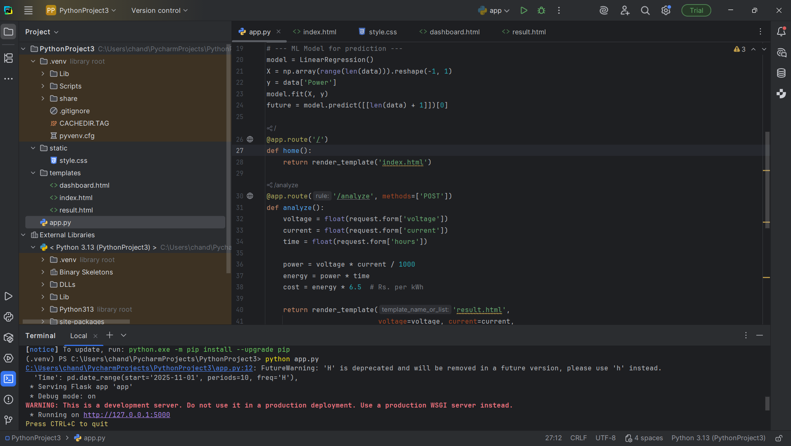
7.OUTPUT SCREENSHOTS

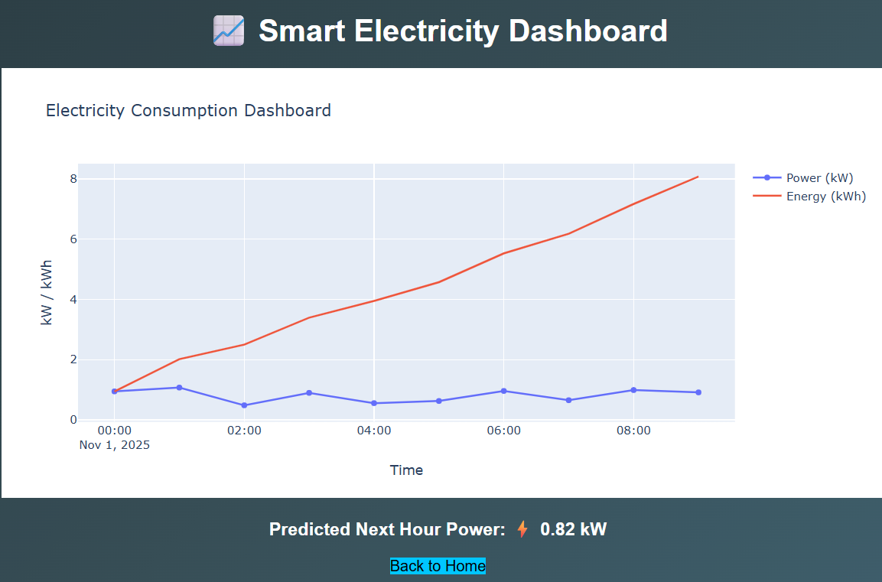
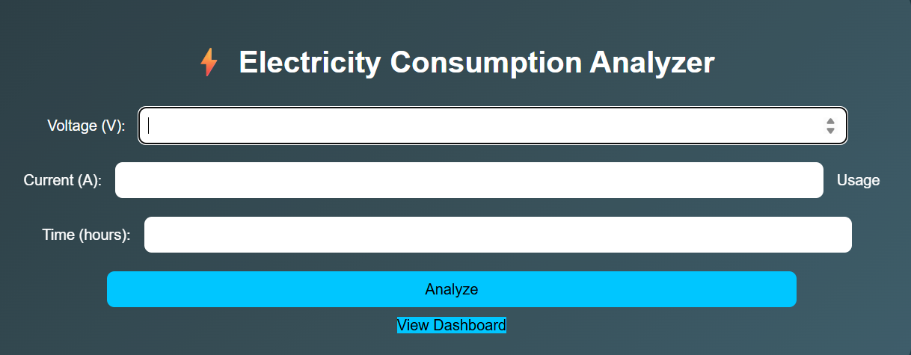



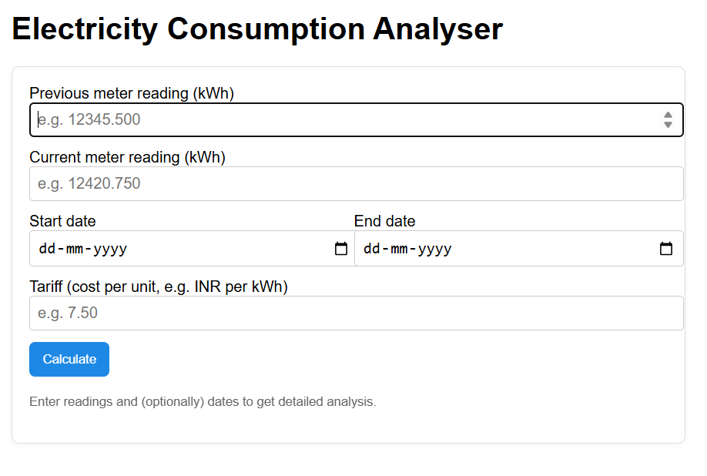
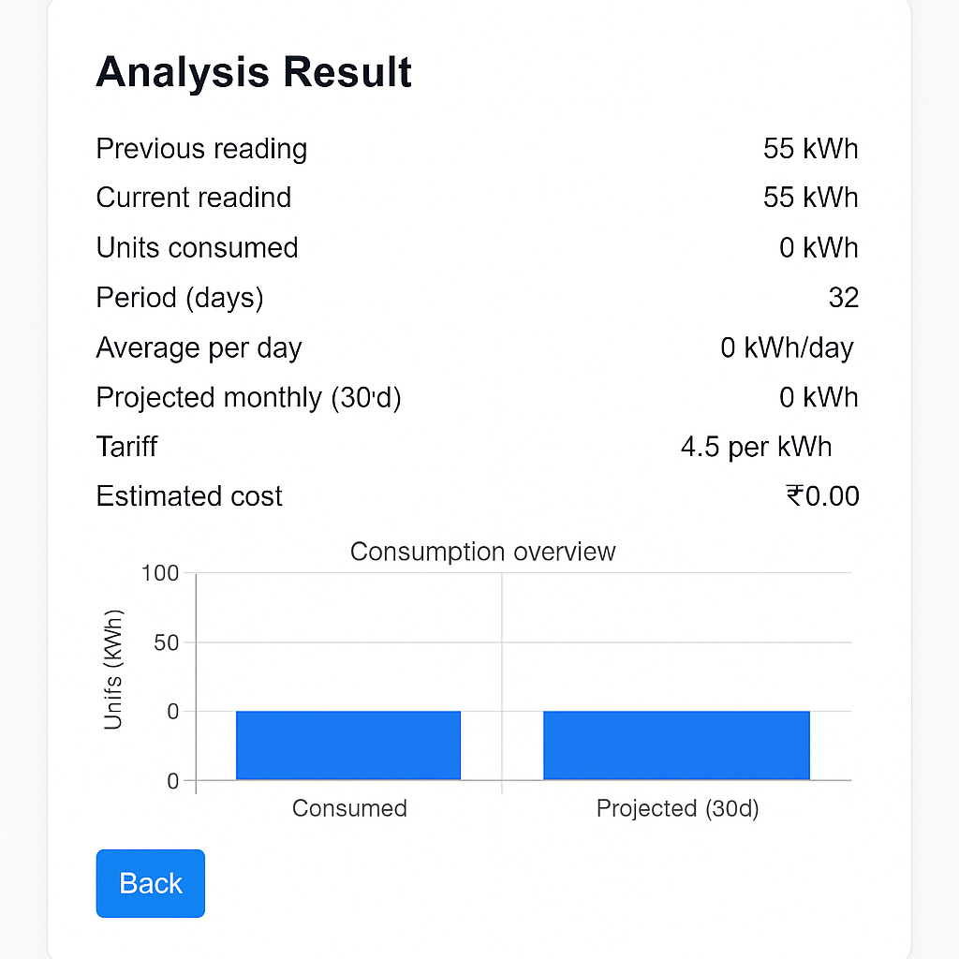

- APPLICATIONS OF THE PROJECT
The Smart Electricity Consumption Analyzer has a wide range of applications across domestic, commercial, and industrial sectors. By combining data analytics, machine learning, and visualization, the system can be used for both real-time monitoring and decision-making. Below are some of the key applications of this project.
• Home Energy Monitoring
The system can be used by homeowners to analyze their daily electricity consumption.
It allows users to calculate power usage, view trends, and estimate monthly bills based on usage duration and tariff rates. This helps in better budgeting and efficient household energy management.
• Industrial Energy Management
Industries consume large amounts of energy for machinery and production.
The analyzer can help monitor energy usage of different devices or units, identify peak usage hours, and optimize operations to reduce energy wastage.
• Educational and Research Applications
The project serves as a practical tool for learning data analytics, web development, and basic machine learning concepts.
Students can use it to understand how electricity data can be processed, visualized, and used for prediction using regression models.
• Smart Building and IoT Integration
The project can be extended by integrating IoT sensors such as current and voltage sensors with microcontrollers (e.g., ESP32).
This enables real-time monitoring of electricity consumption in smart buildings or campuses through a live dashboard.
• Energy Cost Estimation
The system can be used by both domestic and commercial users to estimate the cost of electricity consumption before receiving the actual bill.
This helps users plan their usage during off-peak hours to save on energy expenses.
• Sustainable Energy Planning
By analyzing long-term data trends, the system can support renewable energy management and sustainability initiatives.
It can help compare grid electricity consumption with renewable sources such as solar or wind energy.
• Government and Utility Monitoring
Electricity distribution boards and local utilities can adopt similar systems to analyze consumption data from multiple users.
This aids in understanding demand patterns and planning better distribution strategies.
• Alert and Recommendation Systems
The analyzer can be enhanced to send alerts when consumption exceeds normal limits.
It can also generate recommendations to optimize appliance usage, contributing to lower electricity bills and sustainable living.
• Billing Prediction and Load Forecasting
Using machine learning algorithms, the project can predict upcoming electricity usage and estimate future bills.
This is beneficial for both users and power suppliers to plan for load management and energy distribution.

In conclusion, the Smart Electricity Consumption Analyzer has applications in multiple domains—ranging from household usage analysis to industrial monitoring and smart grid systems. Its scalability and integration potential with IoT and AI technologies make it a versatile and impactful solution for efficient energy management.
- LIMITATIONS OF THE PROJECT
Although the Smart Electricity Consumption Analyzer is an effective and innovative system for monitoring and analyzing power usage, it has certain limitations that can be improved in future versions. These limitations are primarily due to the use of simulated data, hardware constraints, and restricted functionality within the current implementation.
- Use of Simulated Data
The project currently uses randomly generated sample data instead of live readings from physical sensors.
As a result, the system does not provide real-time electricity monitoring unless integrated with IoT devices.
- Limited Dataset for Machine Learning
The machine learning model (Linear Regression) is trained using a small set of synthetic data.
This limits the accuracy and reliability of predictions when compared to models trained on real-world, large-scale datasets.
- No Real-Time IoT Integration
The existing version of the project does not include real hardware components such as current sensors (ACS712) or microcontrollers (ESP32).
Hence, it cannot capture and process live readings automatically.
- Single-User System
The system is currently designed for a single user or single device at a time.
It does not support multiple users, accounts, or personalized dashboards for different users or households.
- Lack of Data Storage and Historical Analysis
The data used in the application is temporary and not stored in a persistent database.
This restricts the ability to perform long-term analysis or generate historical reports of energy consumption.
- Simplified Cost Estimation
The cost calculation is based on a constant tariff rate (₹6.5 per kWh).
It does not consider varying rates, time-of-day pricing, or different categories of users such as residential and industrial consumers.
- Limited Visualization Scope
The dashboard provides only basic graphs for power and energy.
It does not yet include advanced analytics such as comparative analysis between devices, weekly reports, or anomaly detection.
- Dependency on Internet Connection
The Plotly charts require an active internet connection for rendering and interactive visualization.
Without internet connectivity, some visualization features may not display properly.
- No Automatic Alert System
The current version does not provide alerts or notifications when energy usage exceeds a predefined threshold.
Adding this feature would make the system more intelligent and user-friendly.
- Scalability Constraints
Since the project runs on a local Flask server, it is not optimized for large-scale or multi-device deployment.
Future versions would need to be deployed on a cloud platform for better performance and accessibility.

10.BIBLIOGRAPHY
The following references, online resources, and documentation were used in the design and development of the Smart Electricity Consumption Analyzer project. These sources provided essential guidance on Python programming, Flask framework usage, data visualization techniques, and machine learning implementation.
- Flask Documentation – Official Flask Web Framework Documentation
https://flask.palletsprojects.com/
- Python Official Documentation – Language Reference and Libraries
https://docs.python.org/3/
- Scikit-learn (sklearn) Documentation – Machine Learning in Python
https://scikit-learn.org/stable/
- Plotly Official Documentation – Interactive Data Visualization in Python
https://plotly.com/python/
- Pandas Library Documentation – Data Analysis and Manipulation
https://pandas.pydata.org/docs/
- NumPy Library Documentation – Numerical Computing with Python
https://numpy.org/doc/
- W3Schools HTML/CSS Reference – Web Frontend Development Resources
https://www.w3schools.com/
- GeeksforGeeks – Python Flask Projects, Data Visualization, and Machine Learning Guides
https://www.geeksforgeeks.org/
- • Real Python Tutorials – Flask, Pandas, and Plotly Project Implementations
https://realpython.com/
- • YouTube Tutorials – Flask Project Setup and Data Visualization using Plotly
https://www.youtube.com/
- • MDN Web Docs – HTML, CSS, and JavaScript Technical References
https://developer.mozilla.org/
- • OpenAI ChatGPT – Conceptual Guidance and Code Assistance for Flask, ML, and Visualization Integration
https://chat.openai.com/

These references collectively supported the development of this project, ensuring proper understanding of backend web frameworks, data handling, predictive modeling, and modern web visualization techniques.

